1) K8s Cluster Installation  
   a) kubeadm

   b) minikube

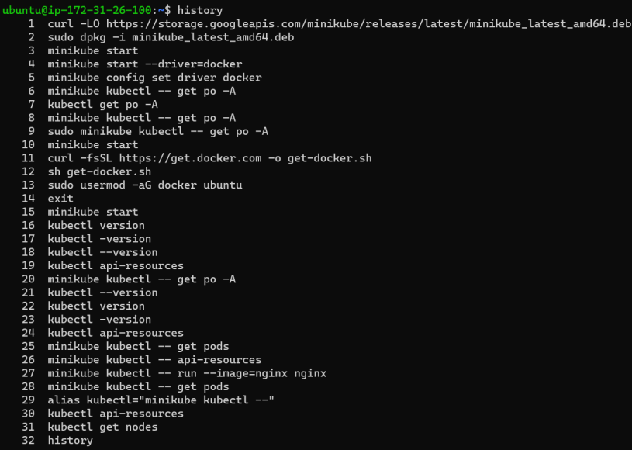  
   c) kind

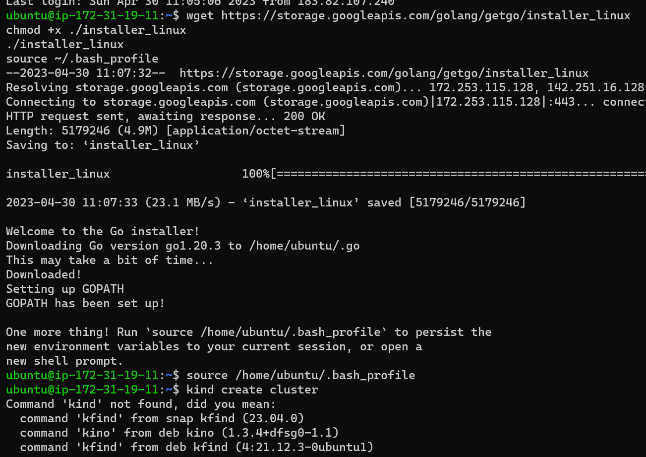

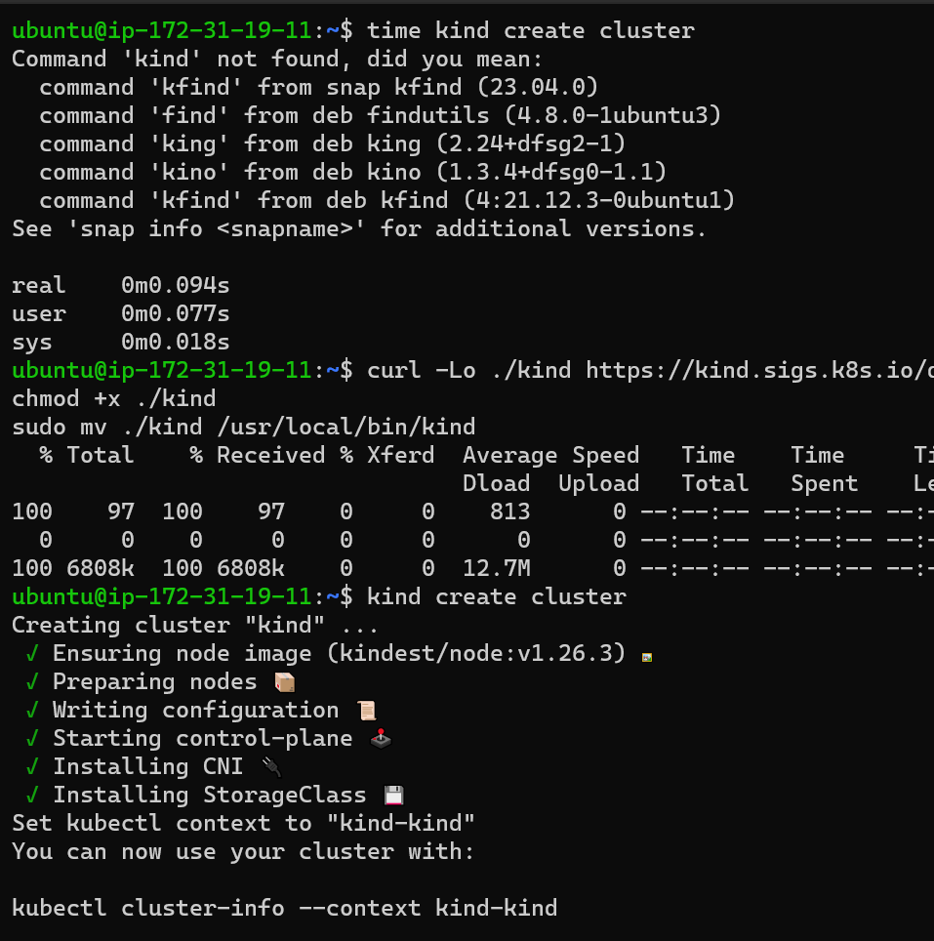

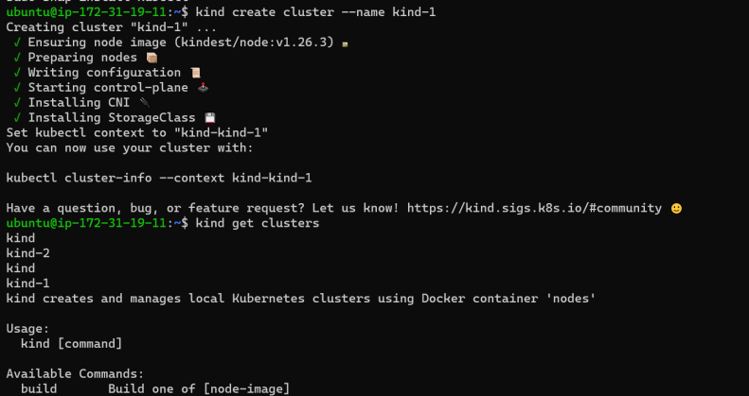  
     
2) A)Writing the Manifest Files for Spc App

apiVersion:

---

apiVersion: v1

kind: Pod

metadata:

  name: Spc-pod

  labels:

    app: spc

spc:

  containers:

    - name: spc-container

      image: sridhar231/spc:3.0.0

      ports:

        containerPort: 8080

B)Writing the Manifest Files for nopCommerce App

---

apiVersion: v1

kind: Pod

metadata:

  name: Nop

  labels:

    app: nop

spc:

  containers:

    - name: nop-container

      image: sridhar231/nop:4.60.2

      ports:

        containerPort: 5000

3) Writing the Manifest File for Game of Life App.

---

apiVersion: v1

kind: Pod

metadata:

  name: Gol-pod

  labels:

    app: gol

spc:

  containers:

    - name: gol-container

      image: sridhar231/nop::1.0.0

      ports:

        containerPort: 8080

4) Creating the Jobs

---

apiVersion: batch/v1

kind: Job

metadata:

  name: job-alpine

spec:

  backoffLimit: 5

  template:

    metadata:

      name: alpine-pod

    spec:

      containers:

        - name: alpine

          image: alpine

          command:

            - sleep

            - 3s

CronJobs

---

apiVersion: batch/v1

kind: CronJob

metadata:

  name: cronjob-alpine

spec:

  schedule: '\* \* \* \* \*'

  jobTemplate:

    metadata:

      name: livedata

    spec:

      template:

        metadata:

          name: alpine-pod

        spec:

          containers:

            - name: alpine

              image: alpine:2.0

              command:

                - sleep

                - 10s

5) Creating the ReplicaSet

---

apiVersion: apps/v1

kind: ReplicaSet

metadata:

  name: jenkins-rs

spec:

  minReadySeconds: 3

  replicas: 3

  selector:

    labels:

      app: jenkins

  template:

    metadata:

      name: jenkins-pod

      labels:

        app: jenkins

    spec:

      containers:

        - name: jenkins

          image: jenkins/jenkins

          ports:

            containerPort: 8080

6) Writing the LABELS and Selecting the LABELS using selector concept

---

apiVersion: apps/v1

kind: ReplicaSet

metadata:

  name: jenkins-rs

spec:

  minReadySeconds: 3

  replicas: 3

  selector:

matechlables:

    labels:

      app: jenkins

  template:

    metadata:

      name: jenkins-pod

      labels:

        app: jenkins

        environment: dev

    spec:

      containers:

        - name: jenkins

          image: jenkins/jenkins

          ports:

            containerPort: 8080